**CIS363—Web Interface Design with Lab**

**Lab Report**

**Professor:** Tevis Boulware

**Lab Number:** 4

**Lab Title:** Navigation, Graphics and Slideshows

**Submittal Date:** 7/29/15

**Objectives:** What was the purpose of this lab?

The purpose of this lab was to utilize some of the more sophisticated animation features offered in CSS3 and to put them to use in concert with the grid layout technique we have been learning about so far this session. The purpose of the lab was also designed to help students learn how to research the internet for helpful tools when building advanced functions into our websites, and to teach us to cite references we use from other sources in a section within the websites we create.

**Results:** Post a screenshot of the working web site/page.

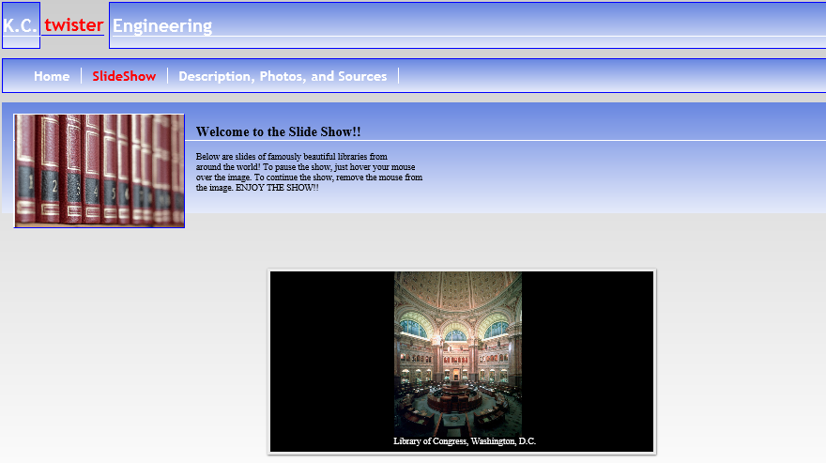

**Conclusions:** What did you learn? Were there any challenges and how did you resolve them? How can what you learned be applied to future Web design projects?

I learned how to implement better animation in my websites and also not to be afraid of some of the more advanced features of CSS3. One challenge that I had involved trying to figure out how to come up with the correct percentages to allow my photographs to appear at the times that I wanted. Now that I am a little more comfortable with CSS3 animation, I going to experiment with some of my own ideas on my own websites. Perhaps I’ll incorporate these techniques in some of the websites I plan to present to potential employers in the future.

|  |  |  |  |  |  |
| --- | --- | --- | --- | --- | --- |
| **Student:** | Kyle Grigsby |  | CIS363B |  | Kyle Grigsby |
|  | Name |  | Program |  | Signature |